1.Food

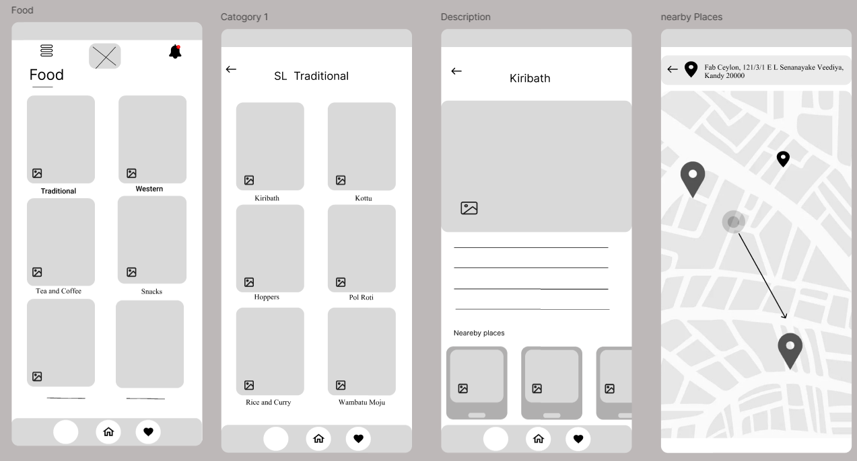

• Categorized recommendations: Sri Lankan Traditional, Vegan, Western, Tea & Coffee, and Snacks.

• Information on each dish and where to try them with integrated maps.